SUMMER INTERNSHIP PROGRAM (SIP) REPORT

# Grouply

**Submitted By**

**Sarvesh Shingare**

**202101050031**

SCHOOL OF COMPUTER ENGINEERING

MIT ACADEMY OF ENGINEERING ALANDI (D), PUNE

*CERTIFICATE*

This is to certify that the “**Summer Internship Program (SIP)” report** submitted by Sarvesh Shingare (**PRN 20210105010031)** is work done by him and is submitted during 2024-25 academic year.

# SIP Guide School - Internship Coordinator

Mr.’s Smita Kulkarni Mr. Nilesh Navghare

# School Dean

Dr. Rajeshwari M. Goudar

# INTERNSHIP BONAFIDE LETTER

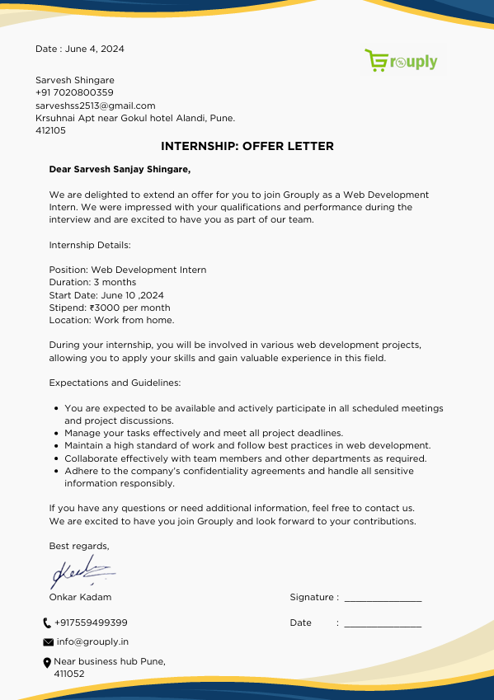

**ACKNOWLEDGEMENT**

I, Sarvesh Shingare (202101050031) would like to convey my gratitude to the Management, Director, and Dean of MIT Academy of Engineering, Pune for emphasizing the 3 - months Summer Internship Program and giving me the platform to interact with industry professionals.

First, I would like to thank Grouply for giving me the opportunity to do an internship within the organization. I also would like all the people that worked along with me in Grouply with their patience and openness they created an enjoyable working environment.

I would like to thank my Head of the Department, Internship Coordinator, and School of Computer Engineering for their support and advice to get and complete an internship in the above-said organization.

I am extremely grateful to my department staff members and friends who helped me in the successful completion of this internship.

# Sarvesh Shingare

**Table of Contents**

|  |  |  |  |
| --- | --- | --- | --- |
| **Topic** | | | **Page No.** |
| 1. | **Introduction** | |  |
|  | 1.1 | Abstract | 6 |
|  | 1.2 | Introduction About Grouply | 6-7 |
|  | 1.3 | Frontend Team | 8 |
| 2. | **Internship Discussion** | |  |
|  | 2.1 | Opportunity Description | 13 |
|  | 2.2 | Role description/statement | 13 |
|  | 2.3 | Scope | 13-14 |
|  | 2.4 | Implementation Details | 15-18 |
|  | 2.5 | Created Pages and components | 19-23 |
|  | 2.6 | Tools/Technologies used regularly | 24 |
| 3. | **Conclusion** | | 25 |

# 1. INTRODUCTION

* 1. **Abstract of SLIP**

I am currently an intern at Grouply. The internship started on 10th June 2024 and will be completed on 16th August 2024. I was hired as a Frontend Developer Intern in this organization.

# Description of Grouply

Grouply is an e-commerce website focusing on group buying, aims to transform the shopping experience by offering wholesale prices through collective purchasing. Here’s a detailed explanation of this approach:

1. **Group Buying Concept**: Grouply leverages the concept of group buying where customers band together to make bulk purchases. This collective approach allows them to unlock wholesale pricing typically available only to large buyers or businesses.
2. **Cost Savings**: By pooling orders, Grouply can negotiate better prices with suppliers, passing these savings on to individual customers. This model enables users to access lower prices for products they might not be able to purchase at a discount on their own.
3. **Revolutionizing Shopping**: The platform aims to change the traditional shopping model by shifting focus from individual purchases to collaborative buying. This can enhance the value proposition for consumers who are looking for cost-effective solutions.
4. **How It Works**:
   * **Join or Create a Group**: Users can either join existing buying groups or create new ones. Groups can be formed based on interests, needs, or specific products.
   * **Collect Orders**: Once a group is established, members commit to buying a certain number of items.
   * **Achieve Discount Thresholds**: When the group reaches the required number of orders, Grouply secures the wholesale prices.
   * **Complete Purchase**: Members finalize their purchases at the discounted rates.
5. **Benefits**:
   * **Lower Prices**: Users benefit from reduced prices through bulk buying.
   * **Community Engagement**: Encourages social interaction and cooperation among users.
   * **Access to Wholesale Goods**: Provides opportunities to purchase products that are typically available only to larger buyers.
6. **User Experience**: The platform likely includes features to facilitate group formation, track order progress, and manage purchases. It may also offer tools to communicate with group members and handle transactions seamlessly.

Grouply is dedicated to offering a diverse range of consumer electronics and accessories. The site specializes in mobile chargers, cables, and related tech gadgets, catering to the needs of a wide array of customers. Grouply is known for its user-friendly interface, designed to provide a seamless shopping experience. With a focus on quality, the platform features products from trusted brands, ensuring that customers receive reliable and durable items.

The website’s design is modern and intuitive, making it easy for users to navigate and find the products they need. A key feature of Grouply.in is the 'New Arrival' page, which is regularly updated with the latest products in the market. This allows customers to stay ahead of the trends and purchase the newest gadgets as soon as they become available. The platform’s commitment to user experience extends to its mobile responsiveness, ensuring that customers can shop effortlessly from any device.

Grouply.in is more than just a shopping platform; it aims to build a community of satisfied customers by focusing on excellent customer service and product quality. The platform’s dedication to continuous improvement is evident in its careful selection of products and attention to detail in website functionality. Grouply.in is fast becoming a go-to destination for those seeking reliable and high-quality consumer electronics.

# Frontend Team

Throughout this project, I had the pleasure of working within a dynamic team of Seven members, where we focused primarily on the front-end development aspects. Our collective goal was to create a visually appealing and highly functional user interface that met the project's requirements and exceeded user expectations.

Our team was tasked with translating design concepts into interactive and responsive web components. We meticulously developed and refined the front-end elements, ensuring that the user experience was intuitive and engaging. This involved using modern technologies and frameworks to build user interfaces that were not only aesthetically pleasing but also highly functional across various devices and screen sizes. Collaboration was key in this phase, as we continuously reviewed and iterated on our designs to align with the project's vision. In addition to our front-end responsibilities, we devoted a significant portion of our efforts to comprehensive documentation. This included creating detailed guides and technical documents that captured the nuances of our development process, design decisions, and implementation strategies. The documentation served multiple purposes: it was instrumental for future developers who might work on the project, provided clarity for stakeholders, and ensured consistency in the project’s evolution. Crafting this documentation was a meticulous task, but it was essential for maintaining the integrity and continuity of the project.

We also engaged with AWS Cloud for a small but impactful segment of the project. This involvement provided us with hands-on experience in integrating cloud-based functionalities. Although our focus on AWS was limited, it offered valuable insights into cloud architecture and its role in enhancing the project’s scalability and performance. Working with AWS allowed us to explore cloud solutions and understand how they could be leveraged to support the project’s infrastructure. The entire experience was profoundly enriching. The collaborative spirit within our team not only fostered an environment of mutual support and learning but also enhanced our ability to tackle challenges collectively. The project underscored the importance of clear communication, meticulous planning, and adaptability.

In conclusion, this project was a beautiful experience that significantly contributed to my professional growth. It highlighted the value of teamwork and provided a comprehensive understanding of both front-end development and cloud integration. The skills and knowledge gained from this experience will undoubtedly serve as a strong foundation for future endeavors.

# INTERNSHIP DISCUSSION

* 1. **Opportunity Description**

During my summer internship, I was appointed as a Frontend Developer at Grouply.in. My primary tasks involved designing and developing the e-commerce website using React.js. This role required a comprehensive understanding of both application development and user interface design. The scope of my responsibilities included creating a responsive and engaging website, optimizing performance, and ensuring a seamless user experience. I was also involved in troubleshooting and resolving any issues related to the front-end, integrating new features, and maintaining the website's functionality. Regular communication with the design team and other stakeholders was essential to align on requirements and ensure the successful delivery of the project.

# Role description/statement

As a Frontend Developer, my role involved the end-to-end development of UI designs and developing of e-commerce website using React.js. I was responsible for translating UI/UX designs into functional code, ensuring responsiveness across devices, and optimizing the performance of the website. My role also included handling documentation related to the development process and collaborating with various teams to meet project goals.

# Scope

The internship focused on the frontend development of e-commerce website. This involved designing and implementing new features, maintaining and enhancing existing components, and troubleshooting any front-end issues. My responsibilities also included ensuring the website’s responsiveness and performance by using React.js and related technologies.

The role required a deep understanding of React.js, CSS, Tailwind CSS and modern web development practices to create a user-friendly and visually appealing site. This included managing state and props in React, implementing media queries for responsive design, and optimizing component loading times. Regular performance monitoring and debugging were crucial to ensure the website functioned smoothly and met user expectations. Additionally, effective communication with the design team and other stakeholders was essential to ensure that the website met the desired specifications and provided a high-quality user experience.

# Implementation

In my role as a Frontend Developer at Grouply, I undertook a range of tasks related to the development and maintenance of the company's website. Below are the ongoing and completed tasks:

**Regular Tasks:**

1. **Website Development and Content Integration:**
   * Developed the main landing page and its subpages, including the navigation bar and footer. This involved implementing the design and functionality based on UI/UX specifications.
   * Added and managed content related to electronics, ensuring that the information was presented in an engaging and user-friendly manner.
   * Utilized React.js for building interactive components and optimizing performance to enhance user experience.
2. **User Interface Optimization:**
   * Focused on ensuring that the website was fully responsive and visually appealing across various devices. This involved implementing media queries and making adjustments to address any issues related to elements going out of frame on mobile screens.
   * Worked on integrating dynamic content and ensuring that the website's functionality met the company’s standards for performance and usability.
3. **Performance Monitoring and Issue Resolution:**
   * Conducted regular performance checks and debugging to identify and resolve any issues that arose during development. This included optimizing component loading times and addressing any functionality problems to maintain a smooth user experience.

* 1. **Created Pages and components**

**Landing Page:**

Designed and implemented the main landing page, which included developing the navigation bar, footer, and various body contents. Integrated key sections such as "Home," "Our Products," "About," "Login," "Sign Up," and "Searchbar" into the navigation bar to enhance user navigation and engagement.Ensured that the landing page was visually appealing and user-friendly, utilizing React.js for interactive elements and optimizing the layout for responsiveness across different devices.

* + - * 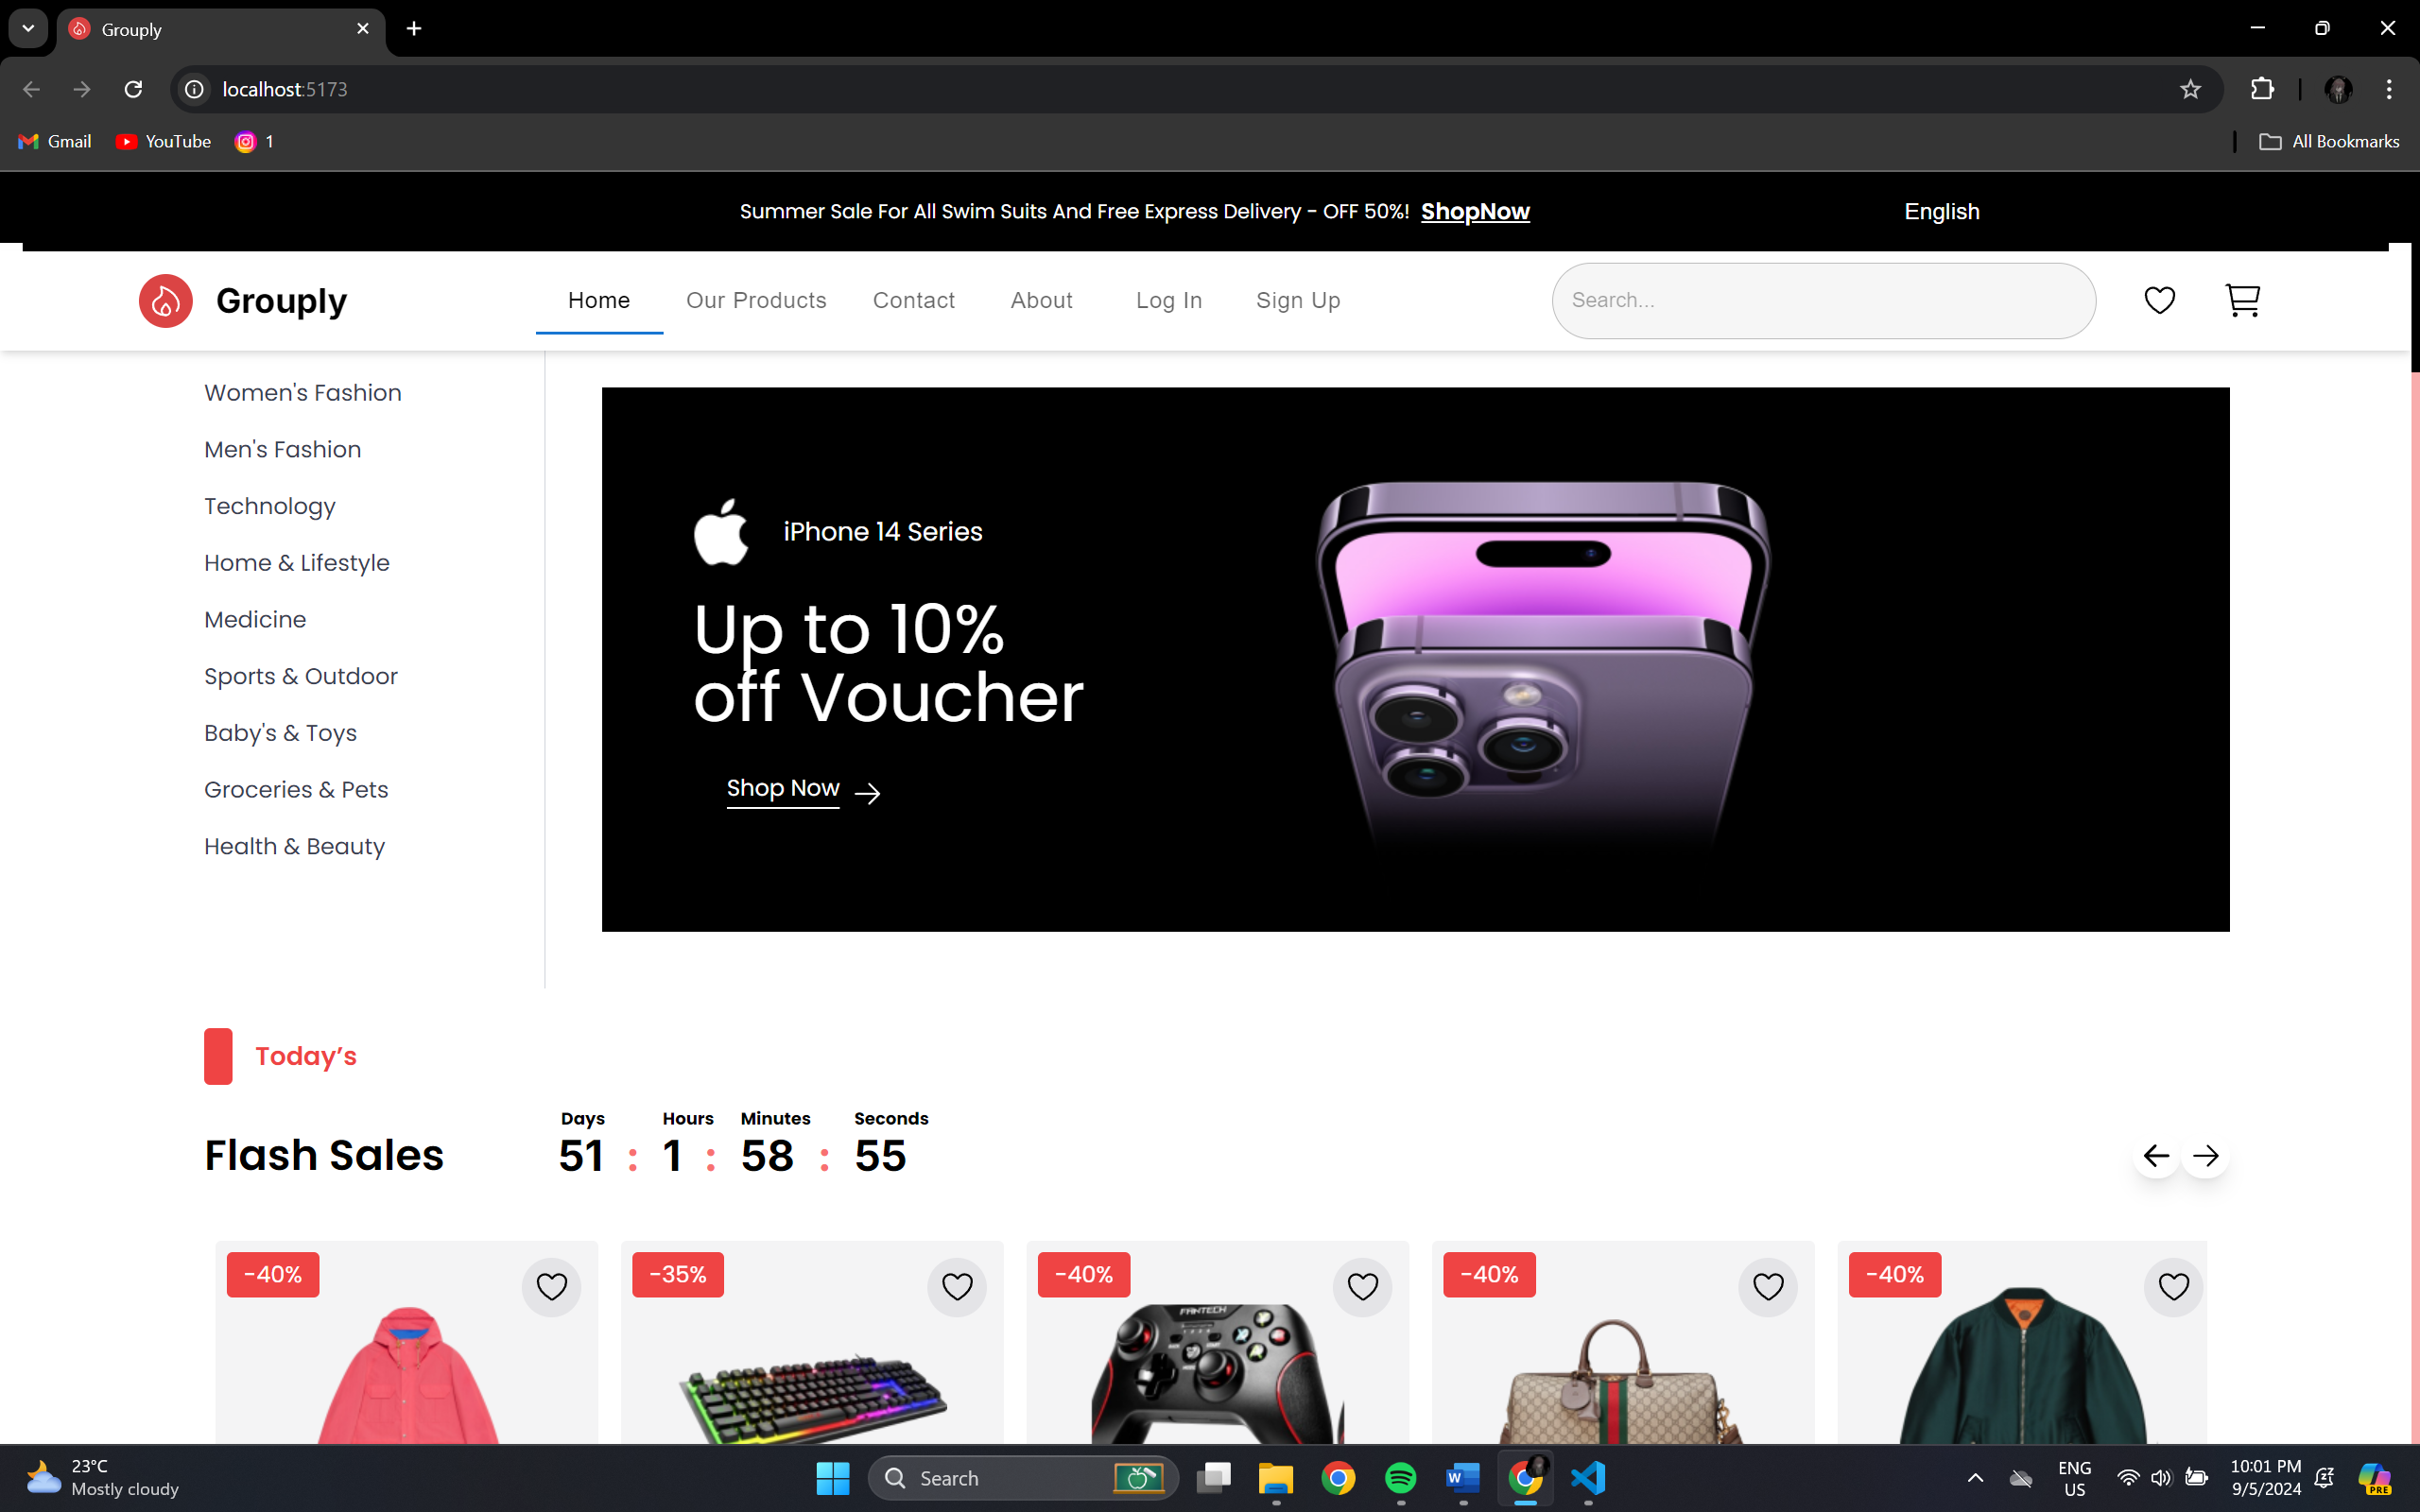

.

**Sidebar Menu Component in React**

I developed a sidebar navigation menu that lists various categories of items for an e-commerce or product-based website.This component is designed with a minimalist approach, focusing on readability and accessibility. The text uses a simple font style, ensuring clarity for users. Each item in the list is rendered as a clickable element, which can be further linked to the corresponding pages of the website.

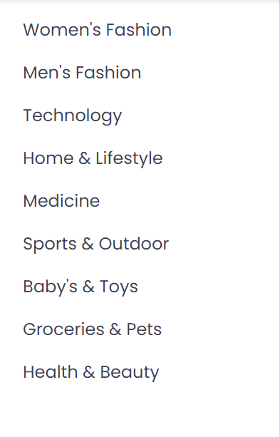

**Flash Sale Component**

I developed a dynamic **Flash Sale** component that displays time-sensitive offers. The component was designed to fetch and display flash sale items from the backend API, updating in real-time. It features a countdown timer to indicate the sale’s remaining duration, ensuring a sense of urgency. I utilized conditional rendering to show the sale only during active periods and styled the component with Tailwind CSS for a clean and responsive layout.

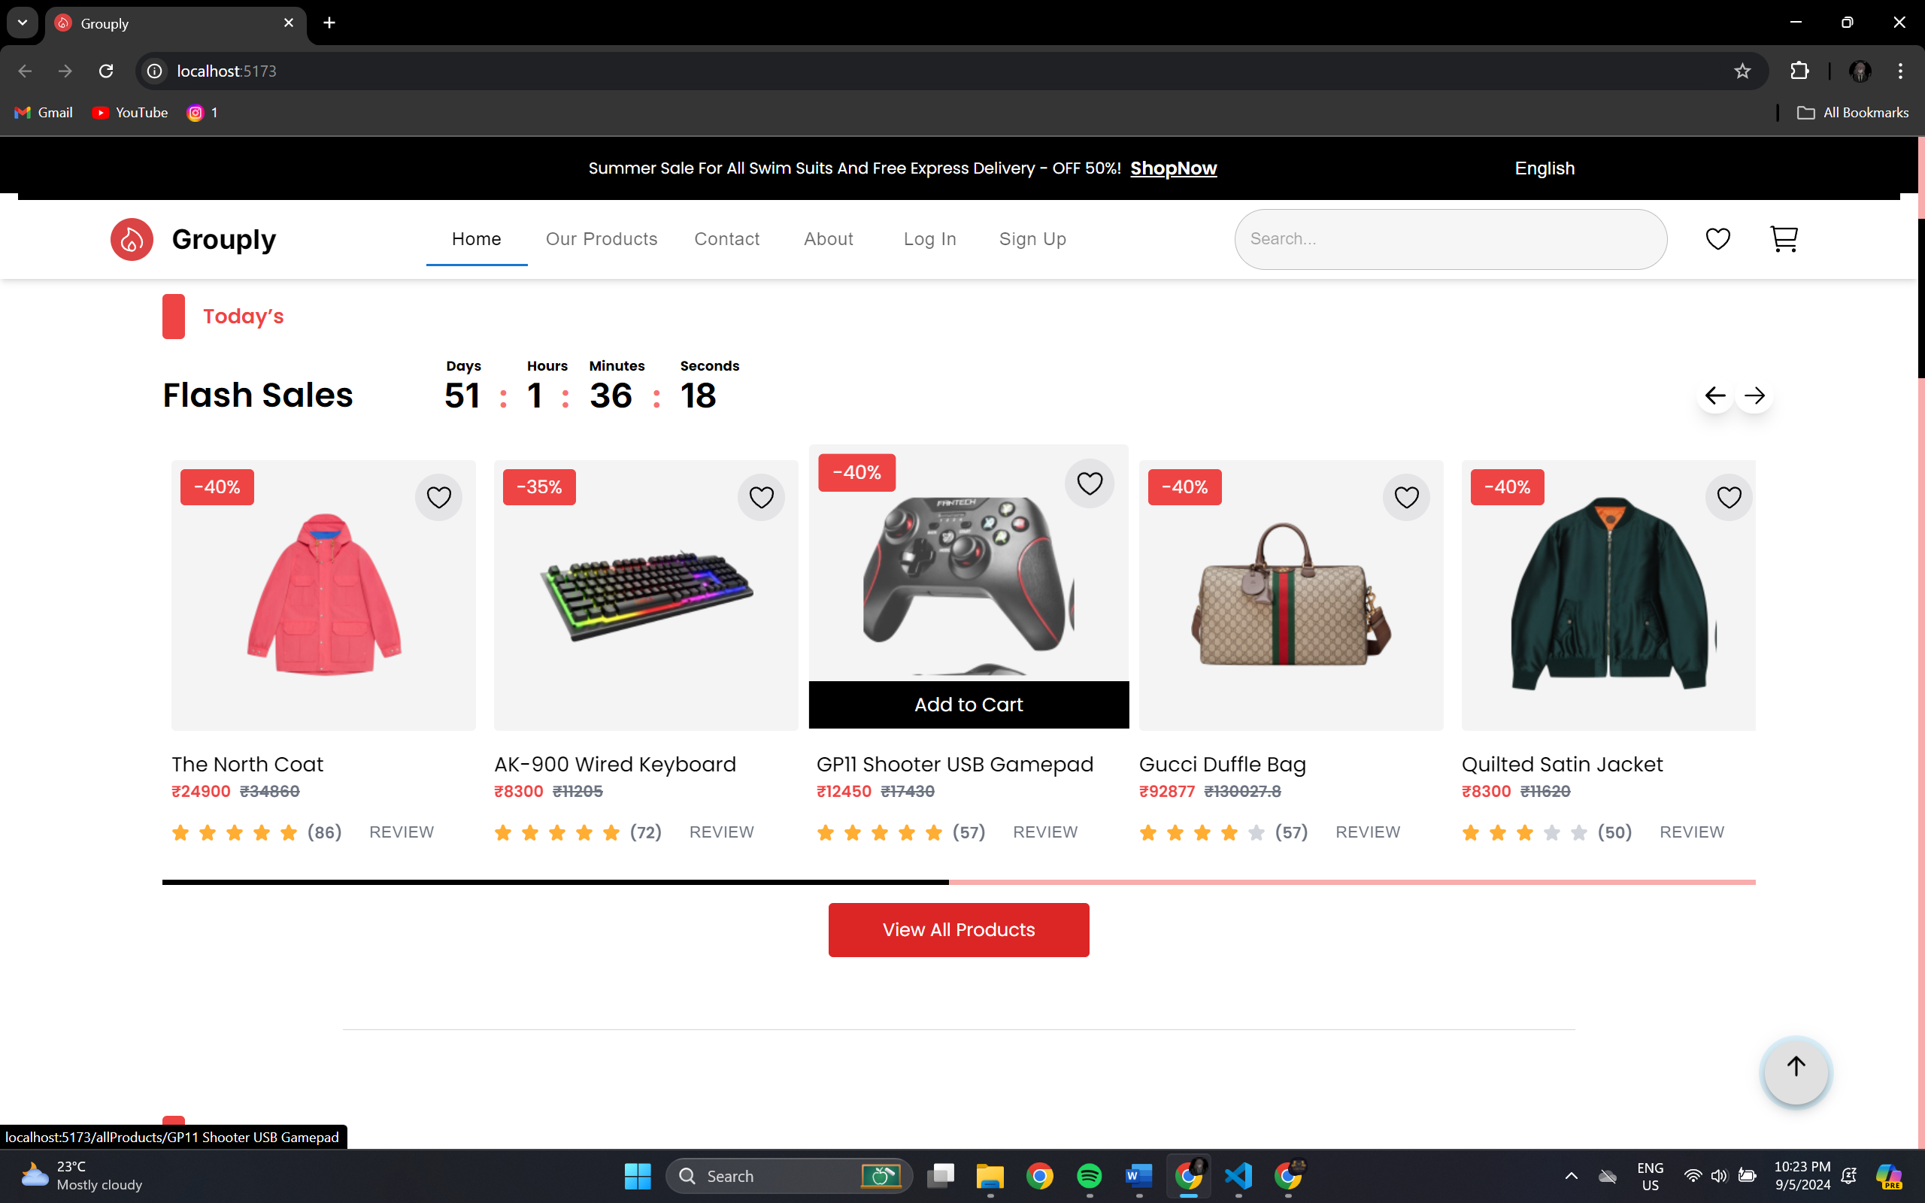

**Category-wise Item Display component**

Implemented a Category-wise Item Display feature, allowing users to view products sorted by categories. Data from the backend API is fetched and displayed in dynamically generated lists, organized by category. I used React's state and props system to ensure that items update seamlessly based on user-selected categories. Tailwind CSS was utilized to create a responsive, grid-based layout, making it easy for users to browse items across different devices.

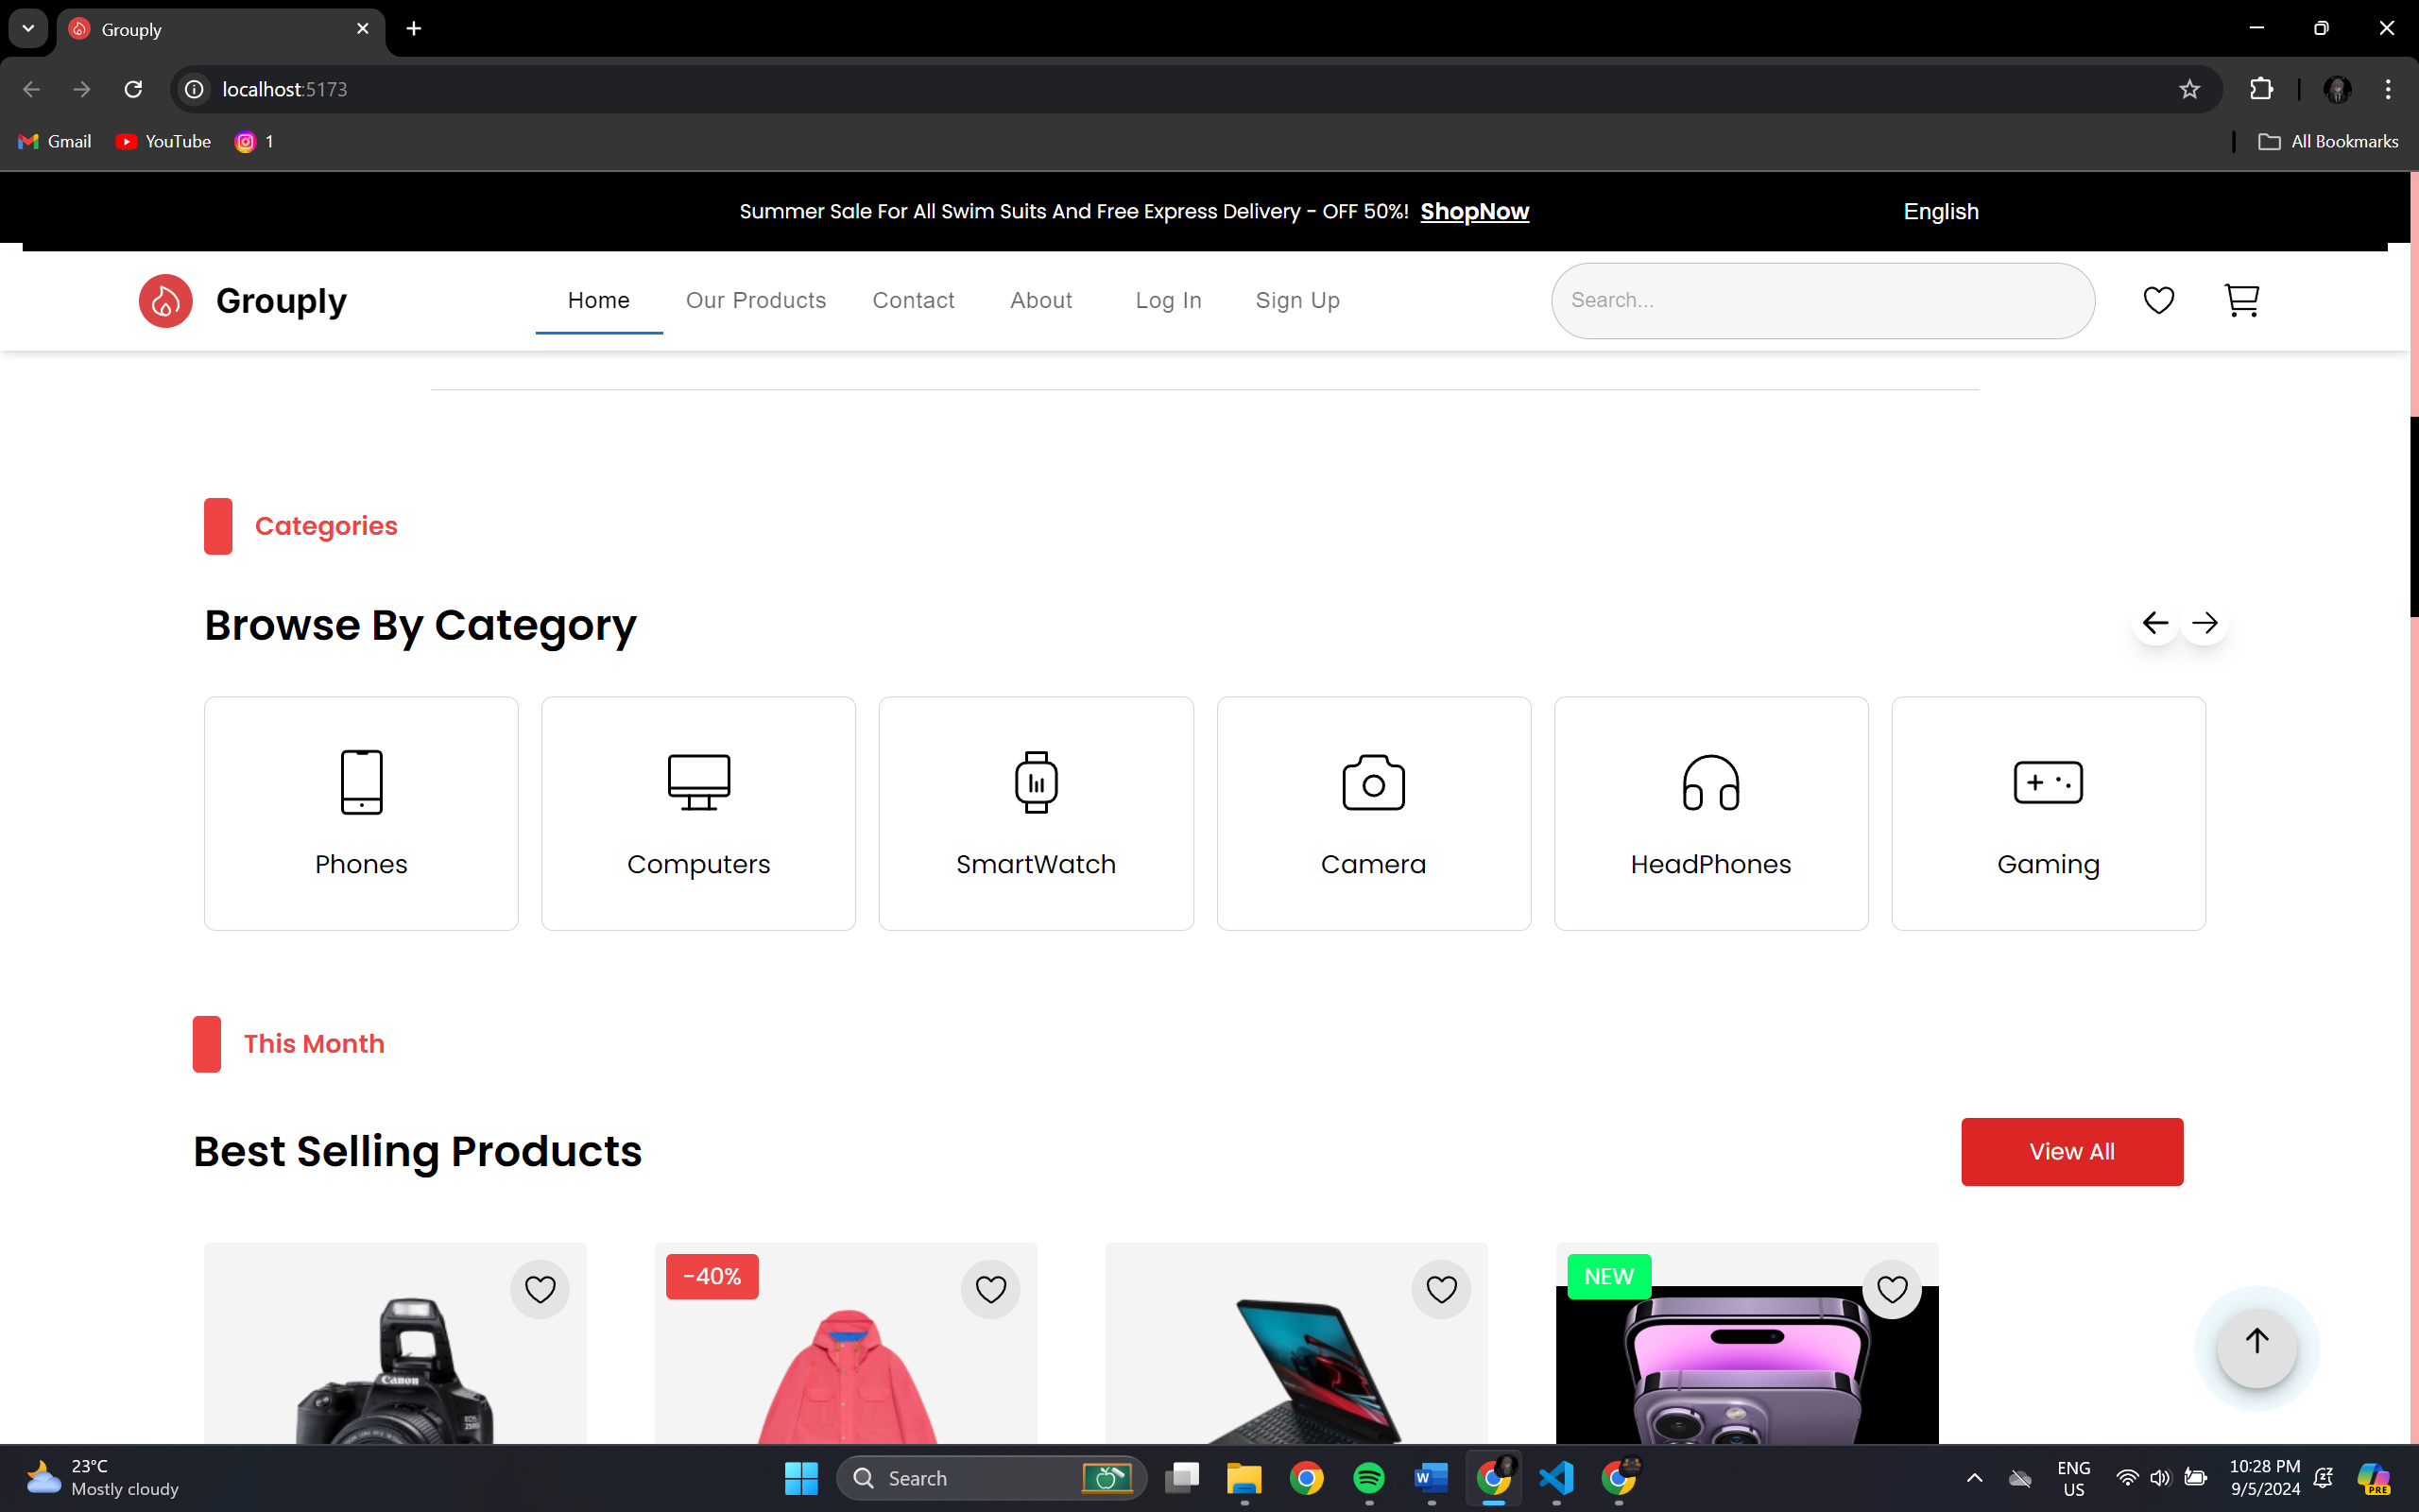

**Our Products**

I created an Our Products page to showcase a complete list of available products. The page was designed with a grid layout for easy navigation and includes pagination for handling large sets of items. I focused on ensuring a responsive design, making the layout adaptable across various devices. Tailwind CSS was used to style the page, providing a clean and modern user interface that enhances the overall browsing experience.

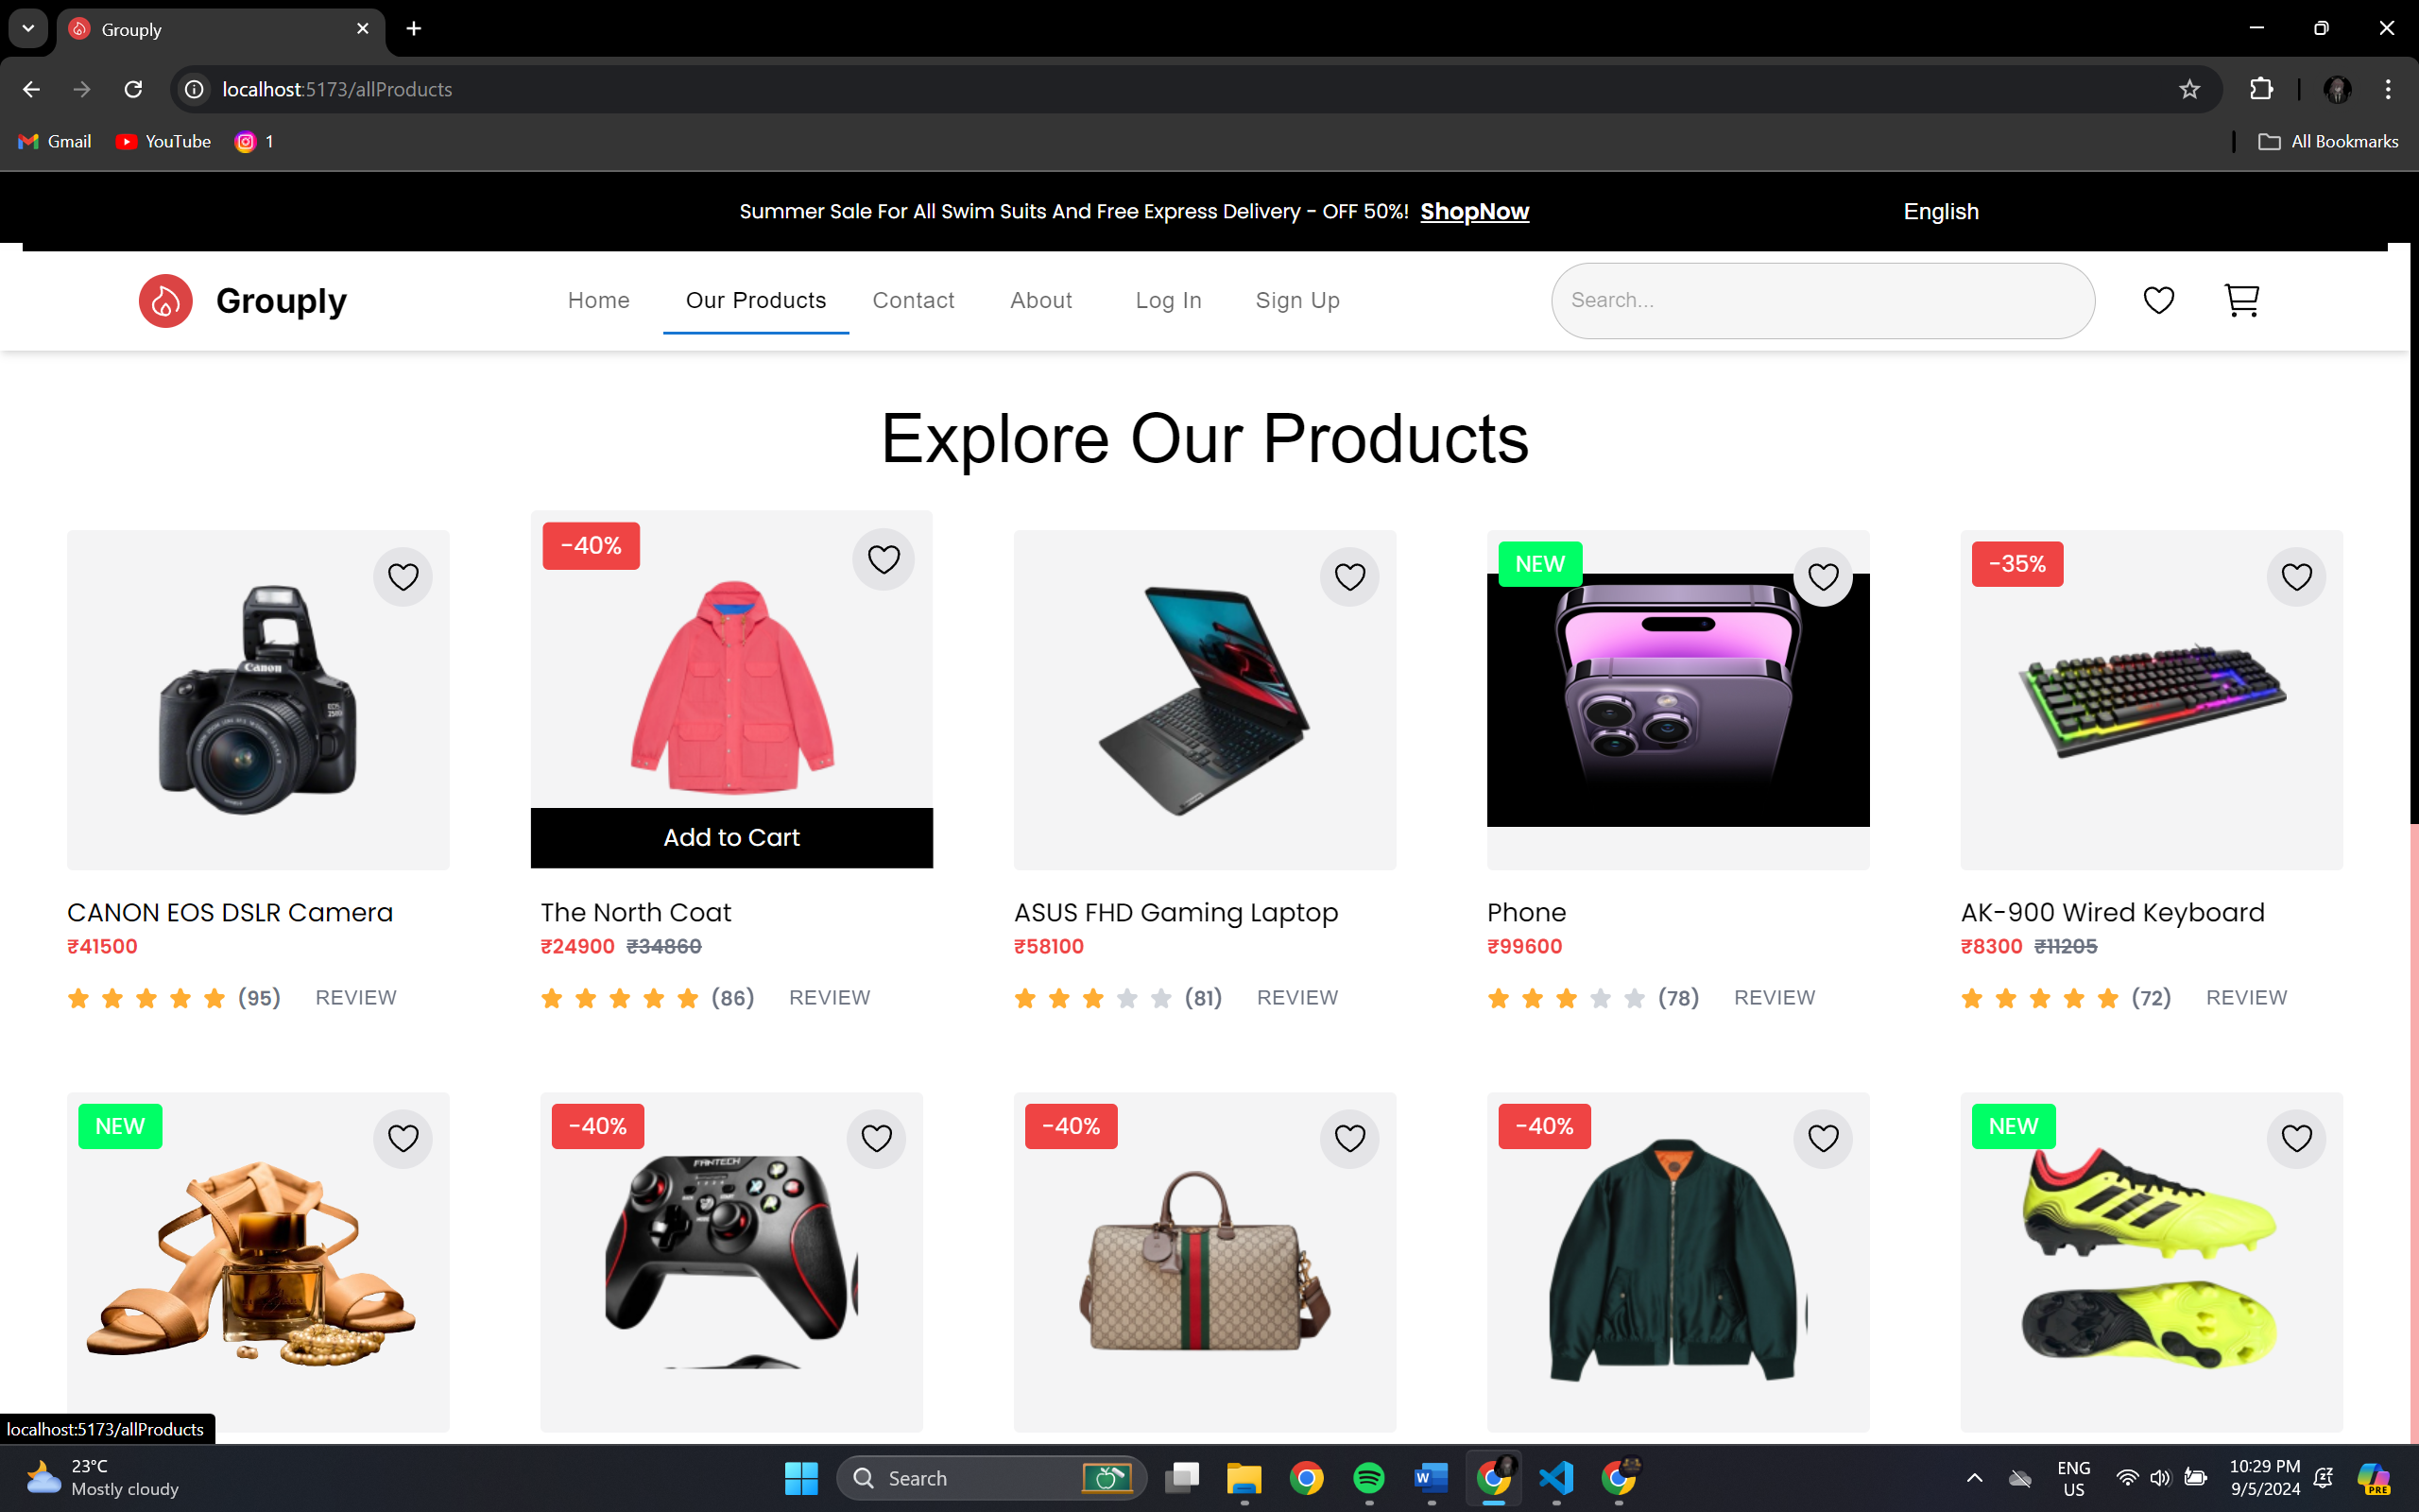

**Login and Signup Page**

I developed a Login & Signup Page that allows users to securely access the application. The page includes form validation to ensure proper input, such as email format and password length, enhancing user experience. The design focuses on simplicity and responsiveness, ensuring the login process is smooth across different devices.

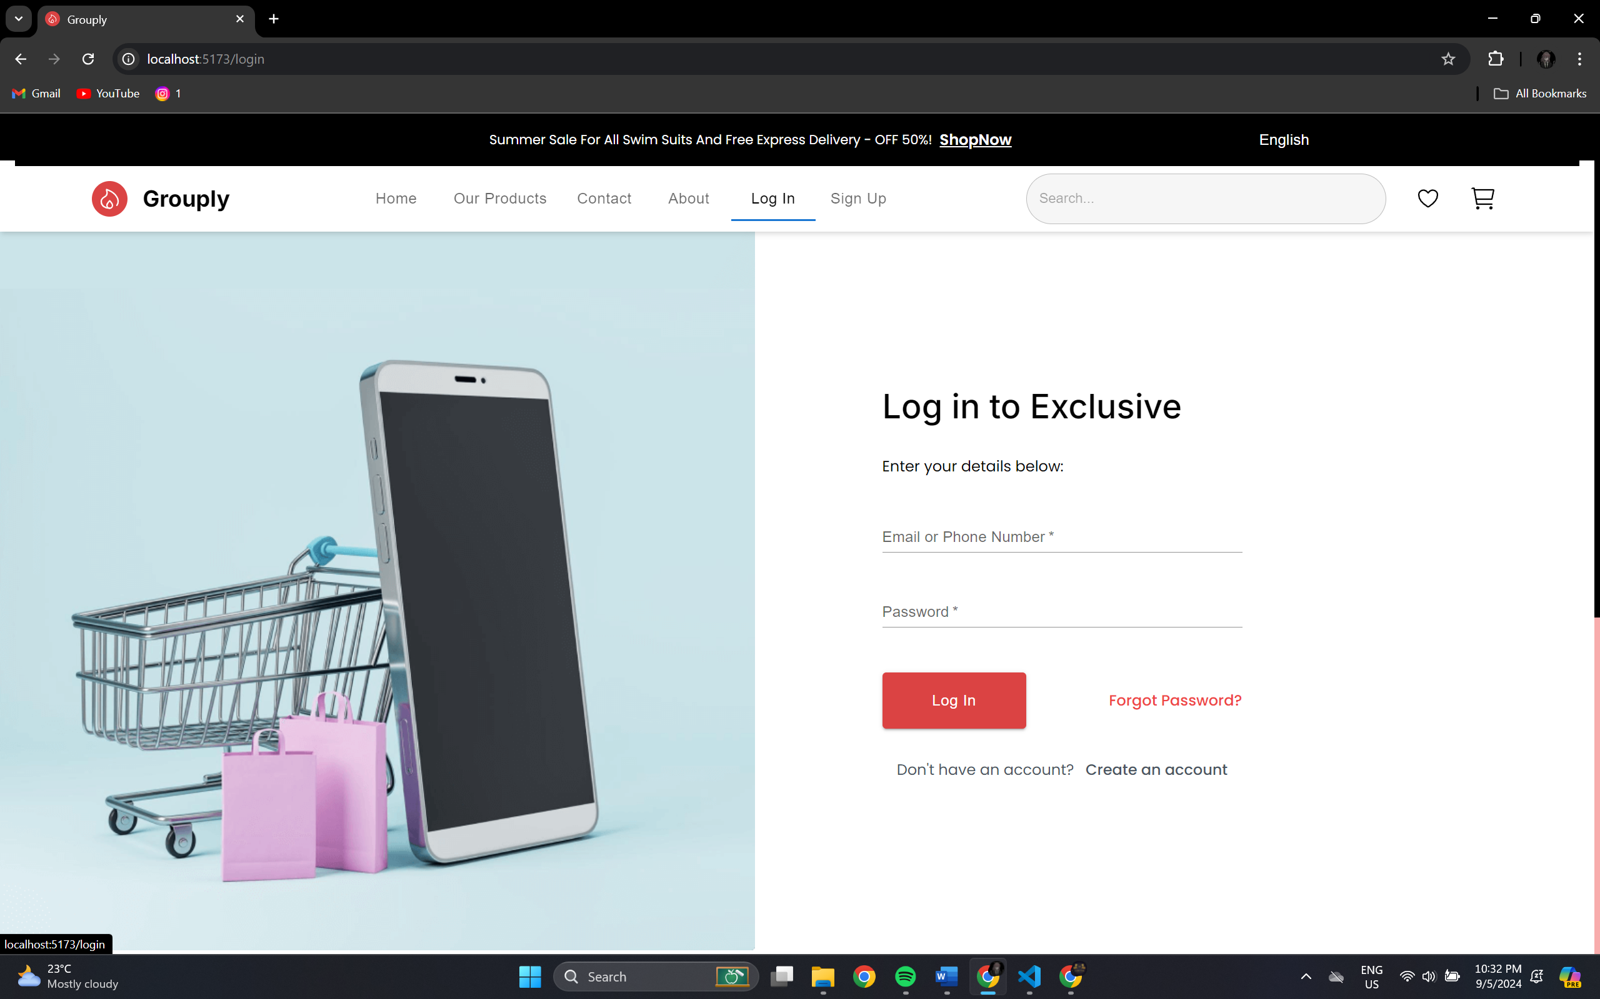

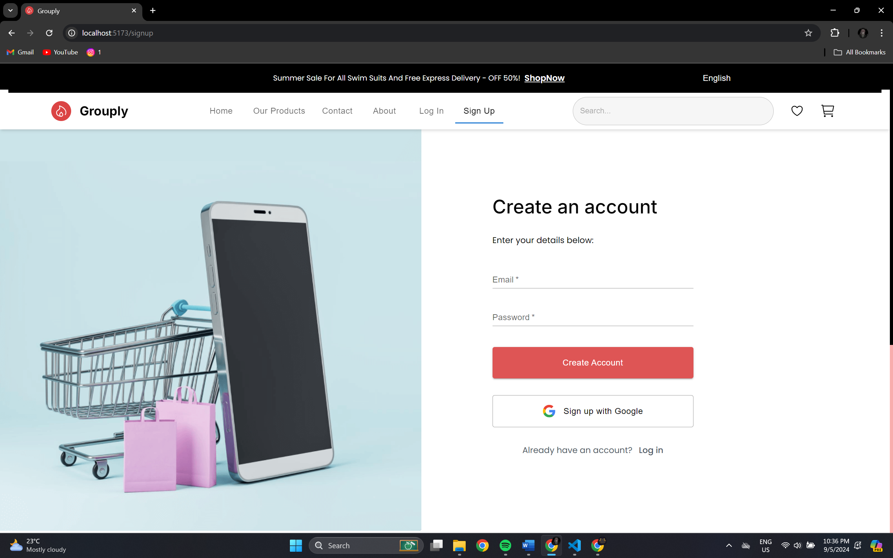

**Product Purchase Page**

developed a Product Purchase Page that allows users to select and purchase products easily. The page includes a product details section, a quantity selector, and a button for proceeding to checkout. The design is fully responsive, ensuring a smooth purchasing experience across devices. Tailwind CSS was utilized for styling, providing a clean and intuitive layout.

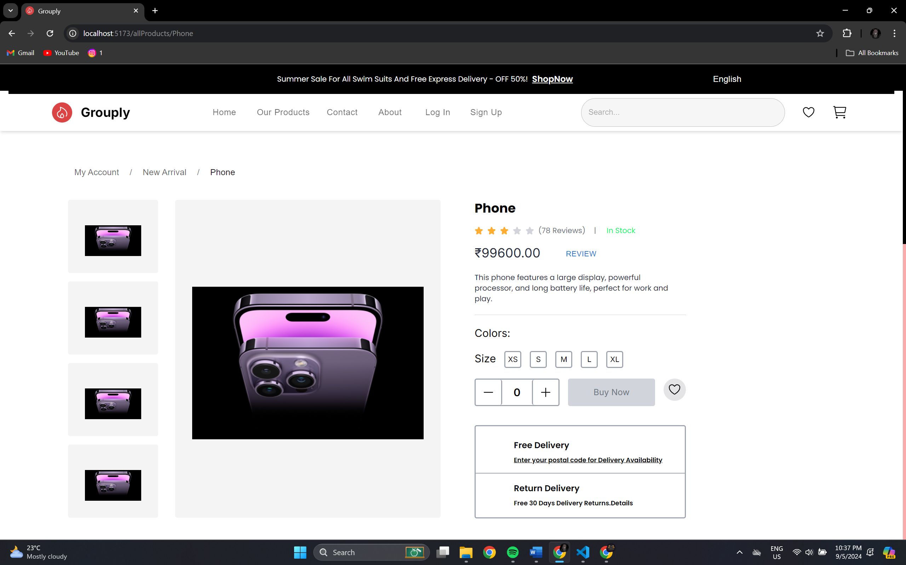

# Cart Page

# Developed a Cart Page that allows users to review and manage their selected items. The page features a list of products in the cart, an option to adjust quantities, and a summary of the total cost. Tailwind CSS ensures a sleek, responsive design for an optimal user experience on all devices.

# 

# Contact Us Page

# Developed a Contact Us Page that enables users to get in touch through a form. The page includes fields for the user’s name, email, subject, and message, along with a submit button. Tailwind CSS is used to create a clean, responsive layout, ensuring easy accessibility and a seamless user experience across different devices.

# 

# New Arrival Page

# Developed a New Arrivals Page that showcases the latest products added to the store. The page features a grid or list view of new items with images, names, and prices. Tailwind CSS ensures a visually appealing and responsive design, making it easy for users to browse and discover the newest offerings.

# Footer Component

# Developed a Footer component that provides essential information and links for the website. The footer includes sections for contact details, social media icons, quick links to important pages, and a brief company description.

# 

# 2.5 Tools/Technologies used regularly

During my internship at Grouply.in, I regularly utilized a variety of tools and technologies to accomplish my tasks effectively. Key tools and technologies include:

* **React.js**: The primary framework used for developing the frontend of the Grouply.in website, allowing for the creation of dynamic and responsive user interfaces.
* **JavaScript, HTML, and CSS**: Essential web technologies used to structure, style, and enhance the website’s appearance and functionality.
* **Version Control (Git)**: Used for tracking changes in the codebase, collaborating with team members, and managing the development process efficiently.
* **VS Code**: The integrated development environment (IDE) used for writing, editing, and debugging code.
* **Browser Developer Tools**: Utilized for testing and debugging web pages, ensuring compatibility across different devices and browsers.

These tools and technologies were integral to the successful completion of my projects and contributed to my technical growth during the internship.

# 3. CONCLUSION

During my internship tenure at Grouply, I had the opportunity to enhance my skills and develop both technically and behaviourally. In terms of technical growth, I learned and applied my knowledge in frontend development, focusing on building and optimizing the e-commerce website using React.js. This hands-on experience provided me with practical expertise in creating responsive, user-friendly interfaces, and managing complex content integration tasks.

Additionally, I gained valuable practical knowledge in working with various web development tools and technologies. This exposure, combined with my involvement in implementing new features and improving existing ones, equipped me with a solid foundation in modern frontend development practices, which are highly relevant and sought after in the industry.

Beyond the technical aspects, my internship experience significantly impacted my personal and professional development. I learned how to collaborate effectively within a team, adapt to organizational culture, and manage my time efficiently while balancing multiple tasks and deadlines.

Overall, this internship provided me with practical and challenging experiences that fostered continuous learning and personal growth. The technical skills I acquired, along with a deeper understanding of teamwork and project management, will positively impact both my professional career and personal development. The knowledge and experiences gained during this internship will serve as a solid foundation for my future endeavours and contribute to my overall success.